Advanced Computer Programming
Assignment :01
Submit from: Ahmad Ali
Submit to: Sir Imran
Roll no:
SU92-BSCSM-F24-229
Section: BSCS-5D

Ahmad Ali
SU92-BSCSM-F24-229
Authentication System:
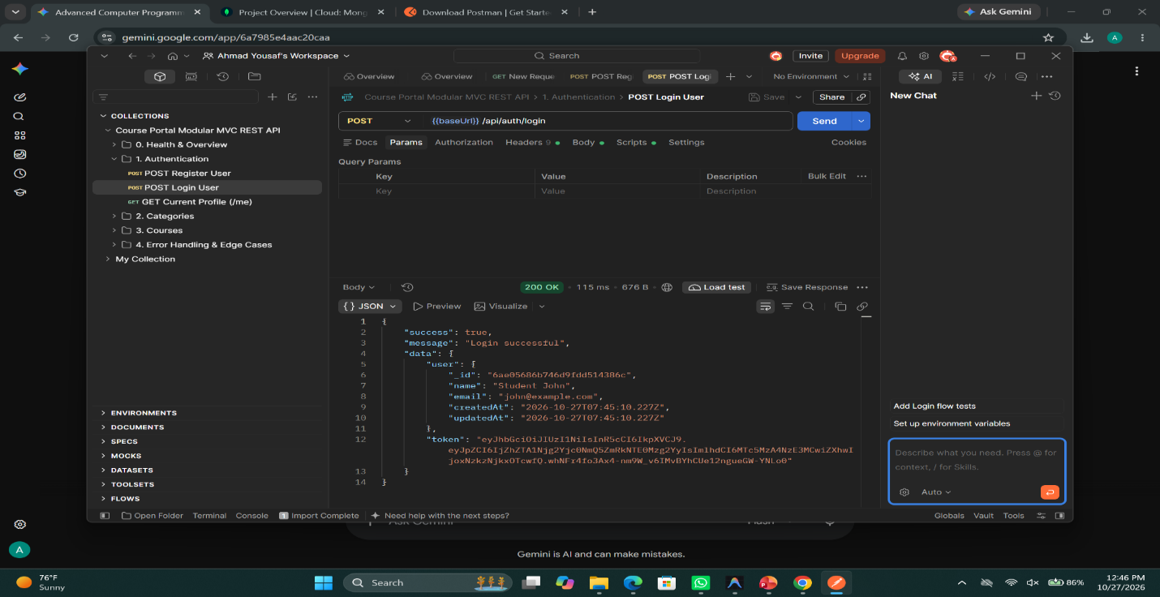
Ahmad Ali
SU92-BSCSM-F24-229
Create Category Module:
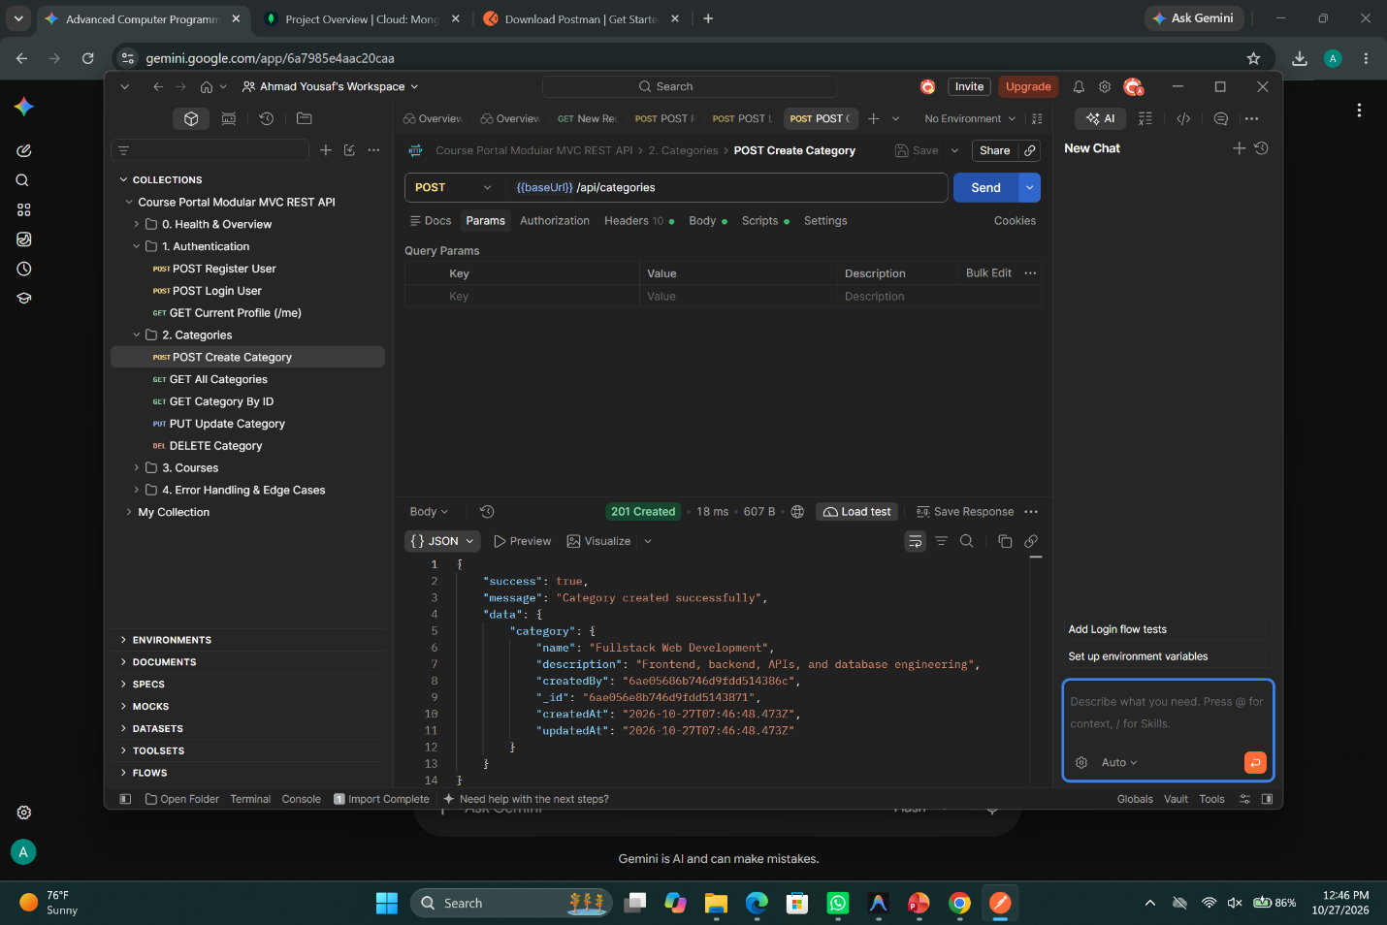

Ahmad Ali
SU92-BSCSM-F24-229
Read Categories Module:
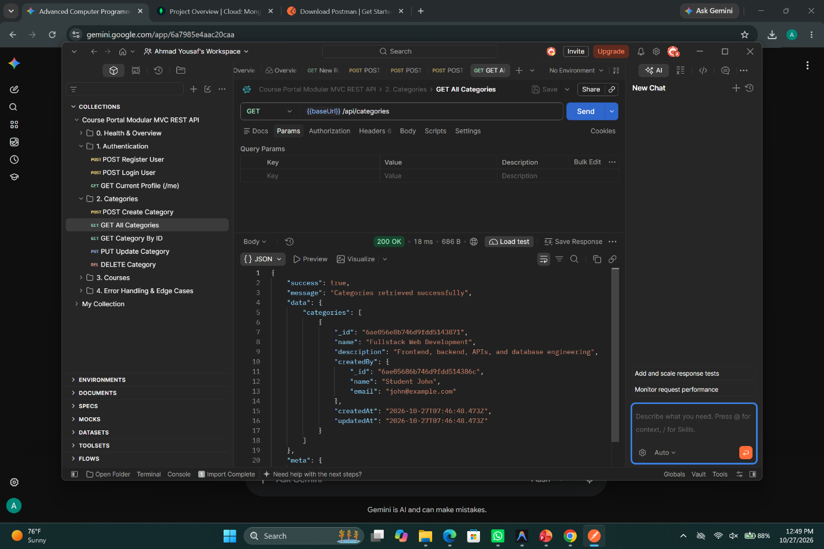

Ahmad Ali
SU92-BSCSM-F24-229
Validation Error Handling:
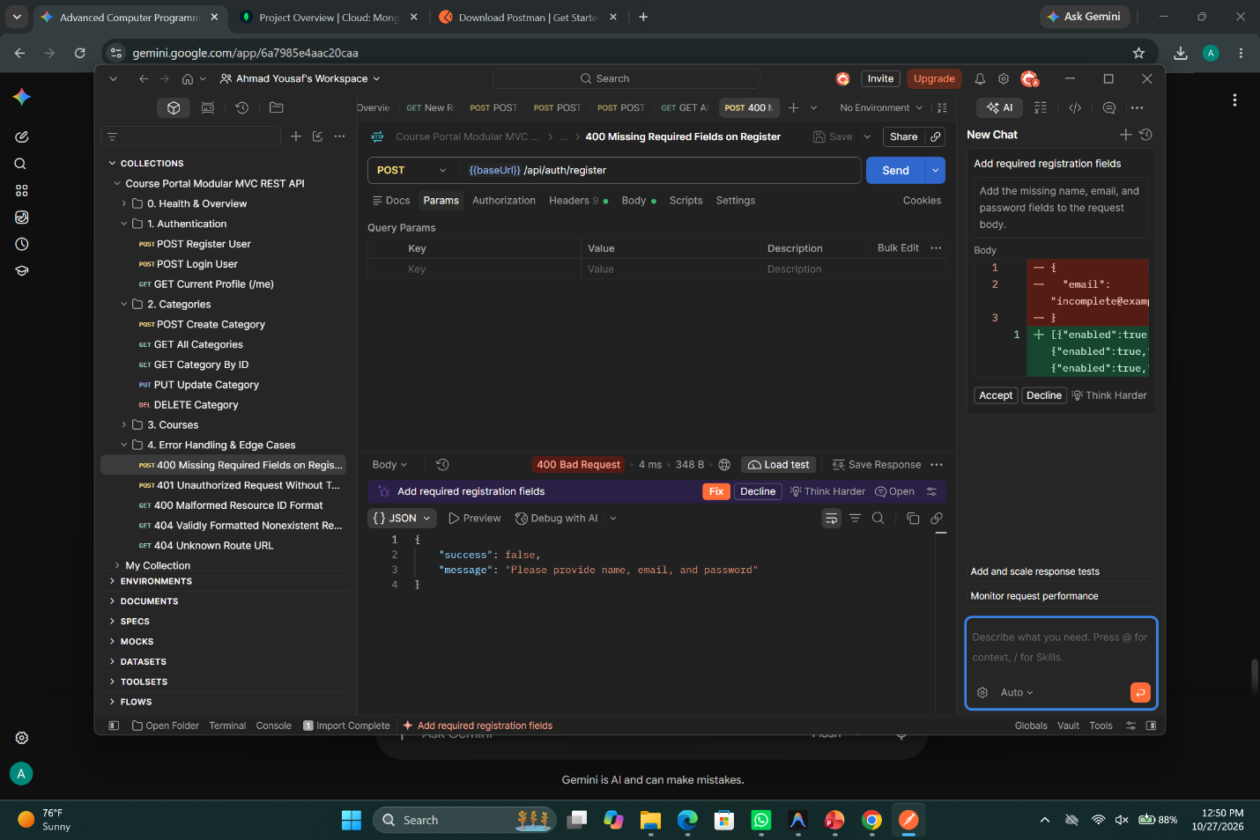

Ahmad Ali
SU92-BSCSM-F24-229
Route Not Found Error:
